**16.3.1**

I don’t know him. Hmm, what is it? That was bad! Oh, no

It was crazy. My computer was okay 1 minutes and the next minutes, my computer was not okay

My computer broken too

What’s about your computer, Khae?

My computer’s fine

Is it?

No one computer working

Oh yeah, my computer is working

Oh

Listen all people! We can work now, because someone here has a computer virus. **All of the computers at the Company Company are broken**. **The IT people are fixing them now**

**After they fix them, can you tell us who has the** **virus.**

Yes, **when I find them I can tell you their name**

**Yes, please, send us their names**

Yes, **we can teach them a lesson**

What is the problem at the office?

* The computer aren’t working

The employees can’t work because **all the computers are broken**

What are the IT people doing?

* They are fixing the computers

**Everyone** wants to know who has the virus

Mr.Jones is in his office. Can you give hime this list?

Those students are bad. I want to teach them a lesson

The customers are in the restaurant. Are they waiting for food?

I would like to know more. Please send me an email

We have to go to the airport. Can you dive us in your car?

Can you help us? We have to fix all of the computers today.

That is Ms.Ellis. You can tell her your name

I want to give you something nice for your birthday.

**Skills Practice**

The computers are broken. The IT people are fixing them now

Take us to the airport

Can you give us a coffee please?

We have to teach them a lesson

John is in his office. Give him this book

We can't tell you their names

The customers are waiting. I have to send them an email now.

**Conversation**

Tod, My computer is not working.

All of the computers are broken. Someone has a virus.

We need to fix them.

The IT people are fixing them now.

Can you tell us who has the virus?

I can’t give you their names now because I don’t know who has the virus.

Can you tell us their names after the IT people fix the computers.

Yes. When I find them. I can give you their name.

Thank you. I want to know who it is?

I do too. I want to teach a lesson.

**Exercise**

I'm sending them an email now.

There's Tom. Can you give him this list?

He send you the email tomorrow.

Those are our books. Can you give then to us?

I don't understand. Can you teach me?

The customers are waiting.

--> OK. We can take to the office.

The customers are thirsty, but there isn't any coffee.

--> That's OK. We can give them tea.

Can you take us to the airport?

--> OK. Is it only you two?

**16.3.2**

**What's a computer virus?**

**It's when your computer is sick**

Oh, Okay. **How does a computer get a virus?**

**Viruses come from the internet or an email**

**Also, there is no internet**. It's bad. **I want everyone to use their laptops**. **You can work without internet**

**I don't have a laptop!**

**Do you have a mobile phone?**

Yes

**Then work on your mobile phone!** I want to see people working. Get to work

Is your foot okay?

Shut up!

Computers can get a virus from an email

Todd wants employees to work on their laptops

Which is true?

--> Employees can work on their phones

Todd hurts his foot

Todd is angry

You can use the Internet at work

You can take your laptop home

My computer has a virus

I don’t know my password

Does this restaurant have Wi-fi?

I love my new mobile phone

Please send me an email

What’s the name of that website?

**Conversation**

Hi Marco, can I use your computer please?

I’m sorry, my computer is broken. The IT people is fixing it

Oh, okay. Then can I user your laptop?

My laptop has a virus

Oh dear, how are you doing at work today?

I’m working on my mobile phone

Woa, you can work on your mobile phone, what can you do?

I can use the Internet and I can send email too

That’s great, can your phone get a virus?

Yes, phone can get viruses too

How does a phone get a virus?

Viruses come from the internet or an email

So, can I borrow your phone?

OK, here you are

**Exercise**

Computer viruses come from the Internet or emails

You can send emails on your mobile phone

What’s a computer virus?

* It’s when your computer is sick

Can I use your Wi-Fi?

Yes, but you need a password

I want to do work at home

* You can take your laptop home to do work

What is on your desk at work?

* There’s a computer on my desk

Can you use your phone at work?

* Yes, you can read emails on your phone

I thinks my computer has a virus

* You need to ask the IT people to fix it

**16.3.3**

Is that your laptop?

Yes, why?

It’s big!

It’s not big. Woa, **your laptop is small.**

**Yes, it’s a small laptop and it’s light.**

**Is it new?**

**No, it’s old**

**It is light!**

Oh, my God, **it’s so heavy**

**It weight’s a lot**. That’s a laptop

Yep. **It’s new and small**

**Is it fast?**

Yes, it’s fast

**My laptop is slow**

That’s a small laptop. Your laptop is big next to her laptop

Can I hold?

Yes

That’s a light laptop

Woa, let’s me hold it. Aanya! This is amazing laptop, it’s so light. I need a new computer. This is old and slow. **I want a fast new laptop**

You can get one. **They are cheap**

They are?

There are only $500

I can buy one on my phone right now

I can, too

What do Marco, Khae ans Aanya talk about?

* Their laptops

Marco ans Khae’s laptop are old

Marco and Khae like Aanya’s laptop

New laptops are not expensive

Macro and khae want to buy a new laptop.

What does Khae say about her computer?

* It’s not big.

What does Marco say about his computer?

* It’s not new.

What does Aanya say about her computer?

* It’s fast

**Conversation**

Marco. Do you want to look at laptop with me?

OK, Are you looking at websites?

Yes. Which one you like?

I don’t like pink. I want to black laptop.

Do you want a big or small laptop?

I want a small fast one.

This one is 1000 $.

That’s really expensive. I only have 500$.

Oh. This one is only 200$.

Yes, but it’s old and it looks slow.

What about this one?It’s 495$. Do you think it heavy?

No. It looks really and It cheaps too! I like it.

Do you want to buy it today?

Oh, Not today.I want to think about it.

Jian: Do you have a computer?

Ling: Yes, but it’s old and slow. It’s ten years old.

Felipe: Do you want this TV?

Gisela: I can’t use the TV because it is big and heavy. My apartment isn’t very big.

Claudia: What do you think about that car?

Enrico: I would like to buy it, but it is very expensive. I only have $500.

Agata: Why don’t you like the bus?

Jannike: It is slow because many people get on it in the morning.

Pam: Which animals do you like?

I like horses because they are big.

How do you go to work?

I use the subway because it’s fast.

Haru: Are you buying a phone today?

Kaito: Yes because my phone is old

Basir: Do you like your new job?

Ismail: No, not really. It is difficult.

**Lesson Exercises**

Ask her to take you to the movies.

This is my new laptop.

This book is heavy.

Your mobile phone is very small.

My computer is not working.

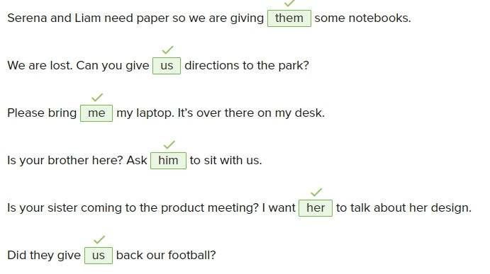

My computer doesn’t work. I think it has a virus.

The wifi in my office doesn’t work.

* Call the IT department.

With the internet, you can use your computer to read and learn about many kinds of things from any place.

Claire: I need to call my friend.

* Irene: Here—take my mobile phone

You can find all kinds of cheap airplane tickets on this website.

I need a new TV. This one is very old.

I can’t bring my computer because it is very heavy.

His computer is very slow. It takes a long time to get onto websites.

Kirby: This is an expensive phone and it’s very light.

* Tess: I want it, but It costs a lot of money.

My laptop is very small and light I can bring it with me in my bag.

